PROGRAM 6
Aim: Demonstrate the use of NumPy for matrix operations.
Code:
#matrix operations
x = np.array([[8,6,3],[2,3,4],[0,0,0]])
y = np.array([[2,5,1],[2,3,4],[5,2,1]])
x + y
c=x.dot(y)
print(c)
x – y
x / y
x % y
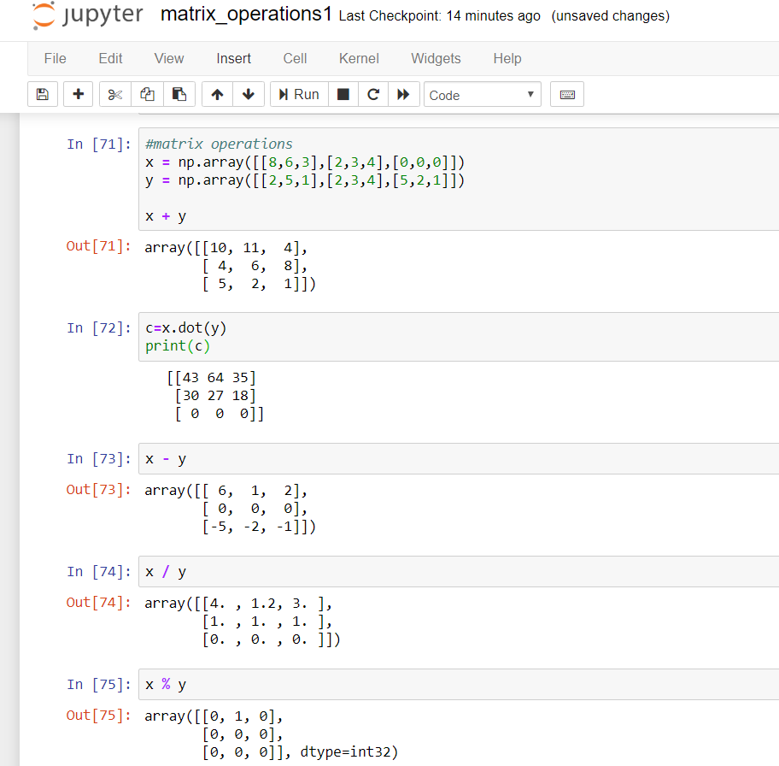
Output:

